Installation Manual of SpinStudioJ

1. Brief introduction for SpinStudioJ
SpinStudioJ is an NMR software based on Eclipse RCP(Rich Client Platform) framework, it offers general functionalities about instrument control, data acquisition, data processing and data analysis. Plug-in architecture based on Eclipse RCP is highly flexible and extensible for the integration of new hardware components and data processing algorithms. Existing third party RCP based plug-ins also can be easily integrated into the software system. Extension point is the general extension mechanism provided by RCP framework.

2. Supported platforms
  - Windows 64bit
  - Linux
  - Unix
  - Mac OSX

3. Supported data types
  - SpinStudio
  - SpinStudioJ
  - varian
  - bruker

4. Software directory lists
SpinStudioJ
|--configuration Plugin configuration.
|--features Plugin management.
|--jre Java runtime environment.
|--logs Log information
|--p2
|--plugins Software plugins.
|--readme Instructions
|--system System directory.
|--config Software configuration directory.
|--data All kinds of data system needed.
|--auto Templates of automated experiment.
|--automation Automation.
|--database Database for automation.
|--template Templates for automation
|--exp_list.xml Experiment list of automation.
|--database System database.
|--pslib Library of pulse sequence.
|--shapelib Library of shape pulse.
|--solvents Solvent list.
|--template Experiment templates.
|--artifacts.xml
|--SpinStudioJ.exe executable file.
|--SpinStudioJ.ini

5. Download
  - 5.1 Download the NMR software from http://www.qone-inst.com/spinstudioj
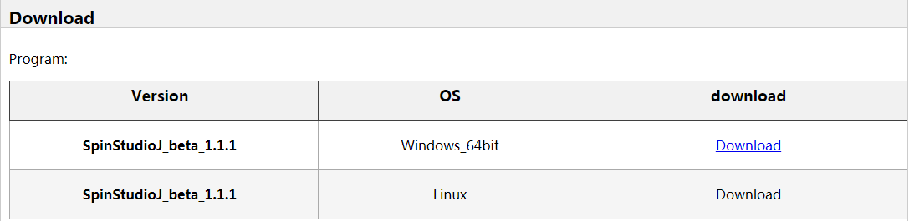
Figure 1. Table for downloading
  - 5.2 Unpack the downloaded file.
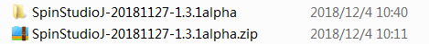
Figure 2. Unpack downloaded file

6.Usage steps
6.1 Launch the software.
Enter the unzipped folder and double click the executable file “SpinStudioJ”, and then the login dialog will display in the screen.
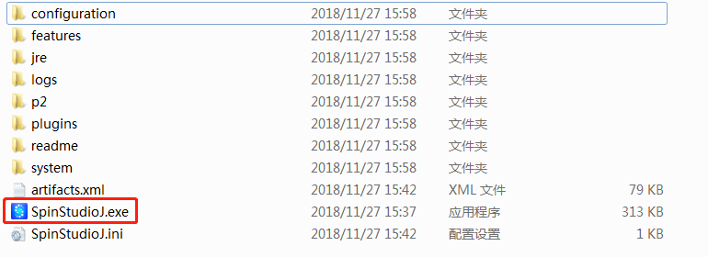
Figure 3. Launch SpinStudioJ
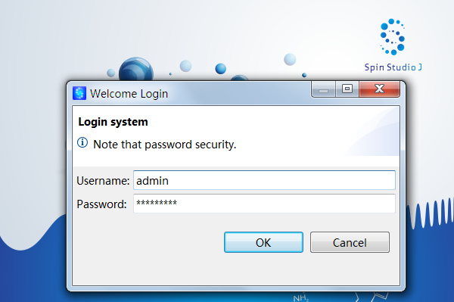
Figure 4. The login dialog
6.2 Login
Use the default user name and password, then click button "OK", and then the root path can be chosen.
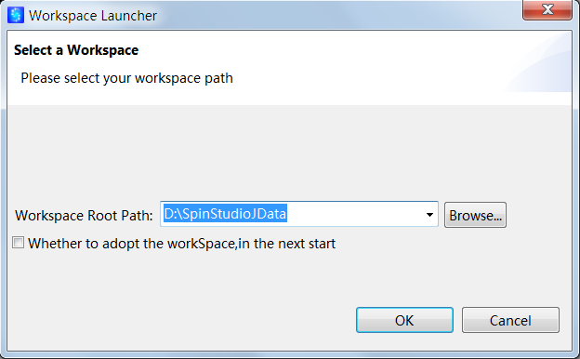
Figure 5. Choose the root path
6.3 Choose Root Path
Click “Browse” button to choose a directory as root workspace path. Then Click button "OK", the main window of SpinStudioJ will display.
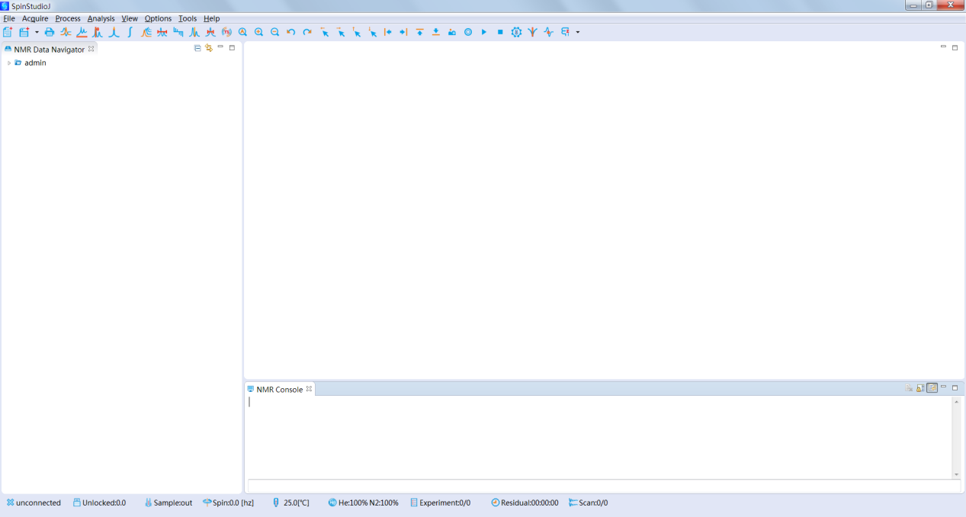
Figure 6. The main window of SpinStudioJ
6.4 Import the NMR data
Click“File/Import” in the main menu, and then SpinStudioJ will popup a dialog.
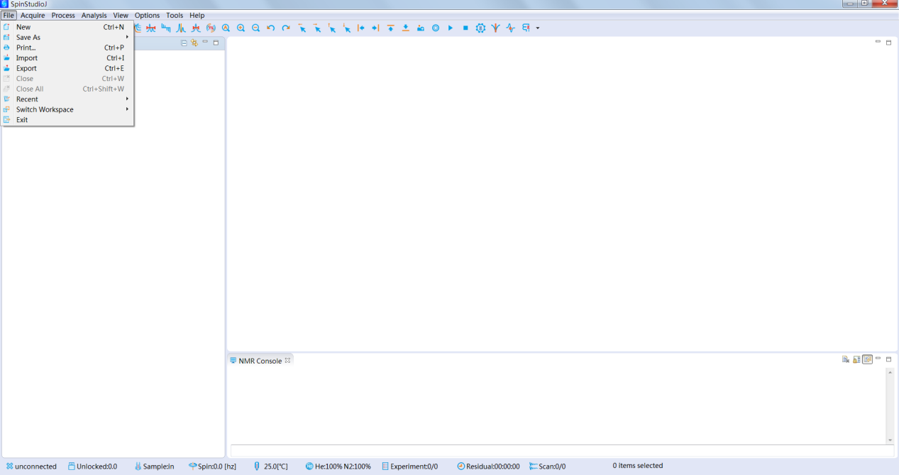
Figure 7. Open the NMR data
6.5 Choose NMR data
Click "Browse" button to choose the data directory, and then select the data you need to import, as well as select the target path; then Click button "Finish".
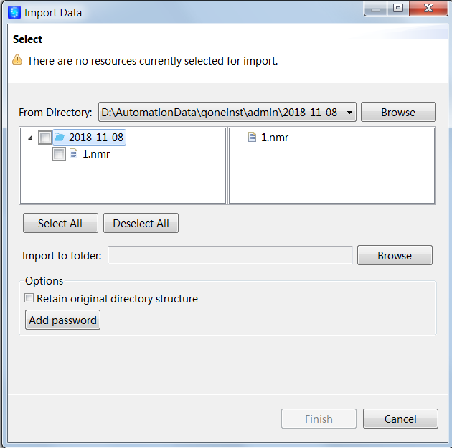
Figure 8. Dialog for import NMR data
Notes: Click "Browse" button to choose the data directory. SpinStudioJ supports data type: SpinStudio, SpinStudioJ, Varian and Bruker, other data formats will be supported in the future. NMR data of SpinStudioJ’s format(the file names end with “.nmr”) can be copied to user’s data directory, and then the NMR data will be displayed in the view of data navigator.
6.6 Open the NMR data
Double click the NMR file in the view of data navigator, and then the NMR data will be displayed in the main window.

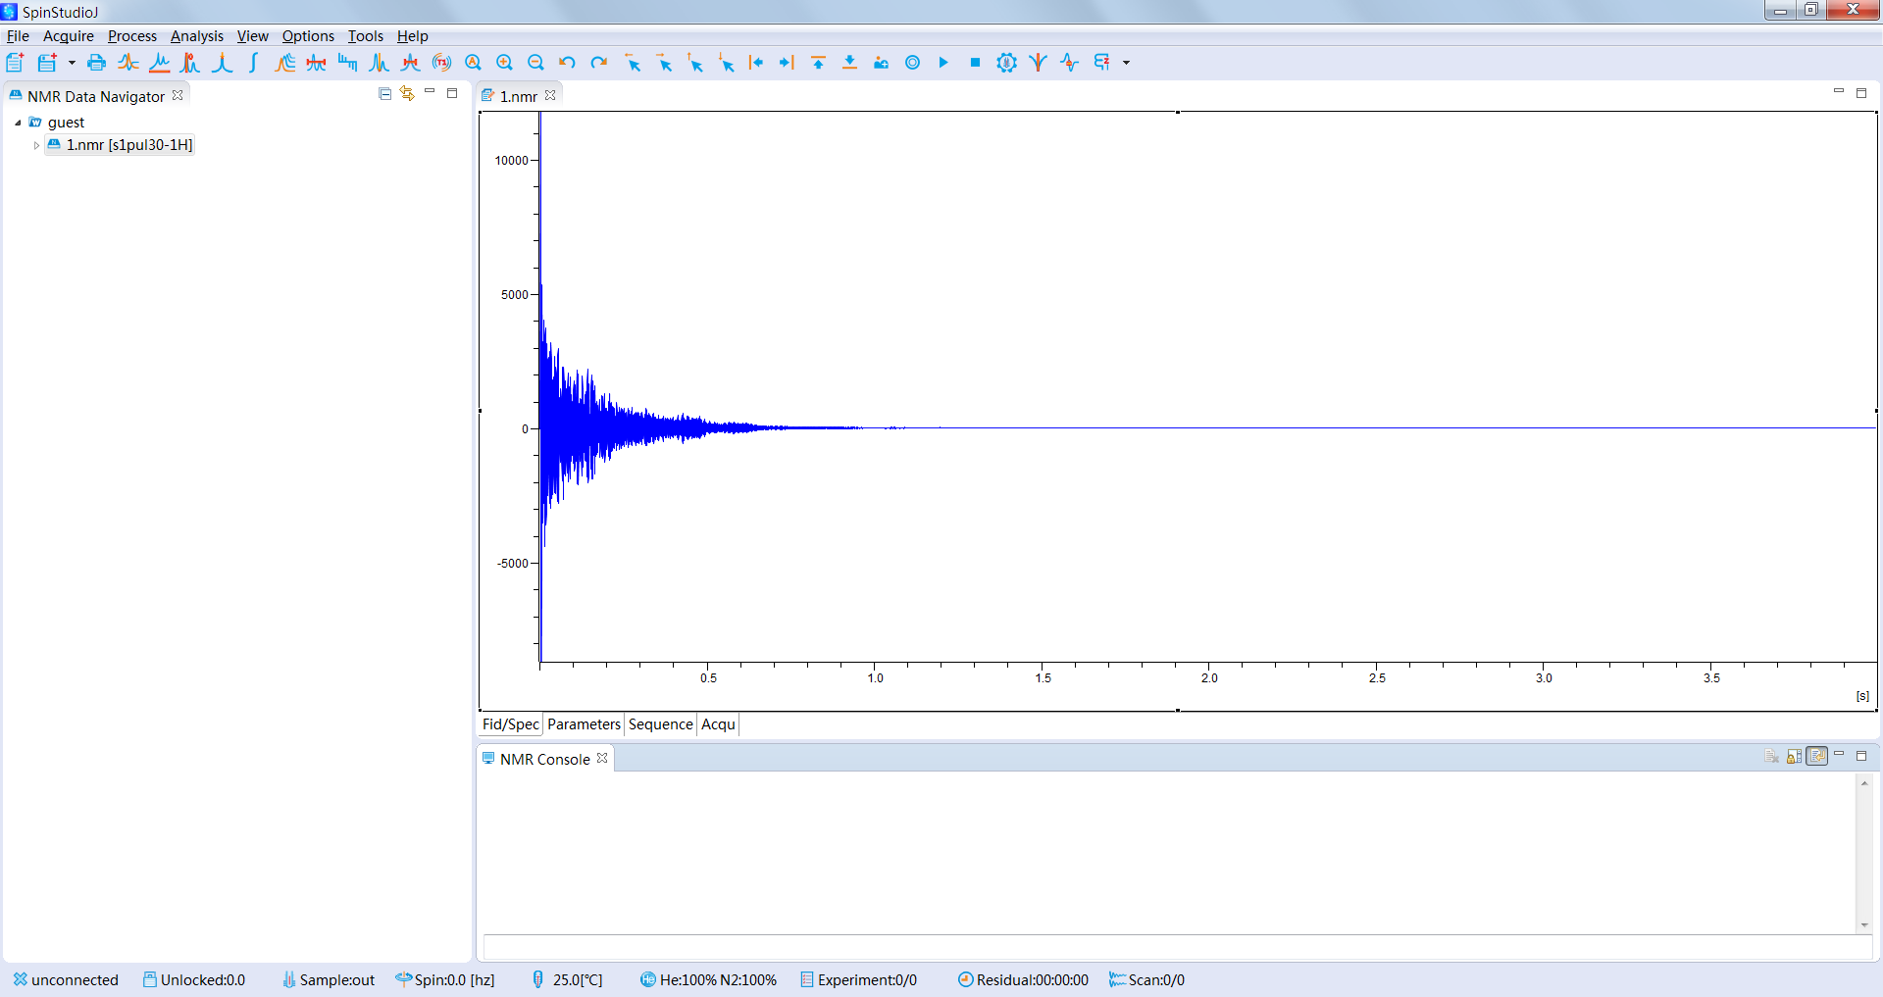
Figure 9. The FID of an NMR data

6.7 New experiment
Click the button in the toolbar:, then SpinStudioJ will popup a dialog.
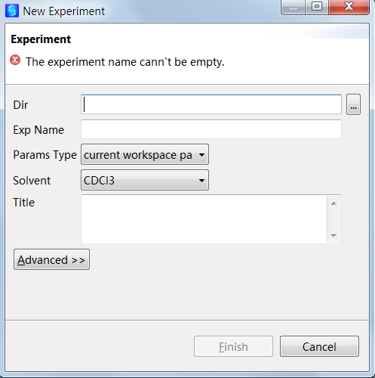
Figure 10. New experiment

6.8 fast Fourier transform
Input “ft” command in the command line at the bottom of the main window.
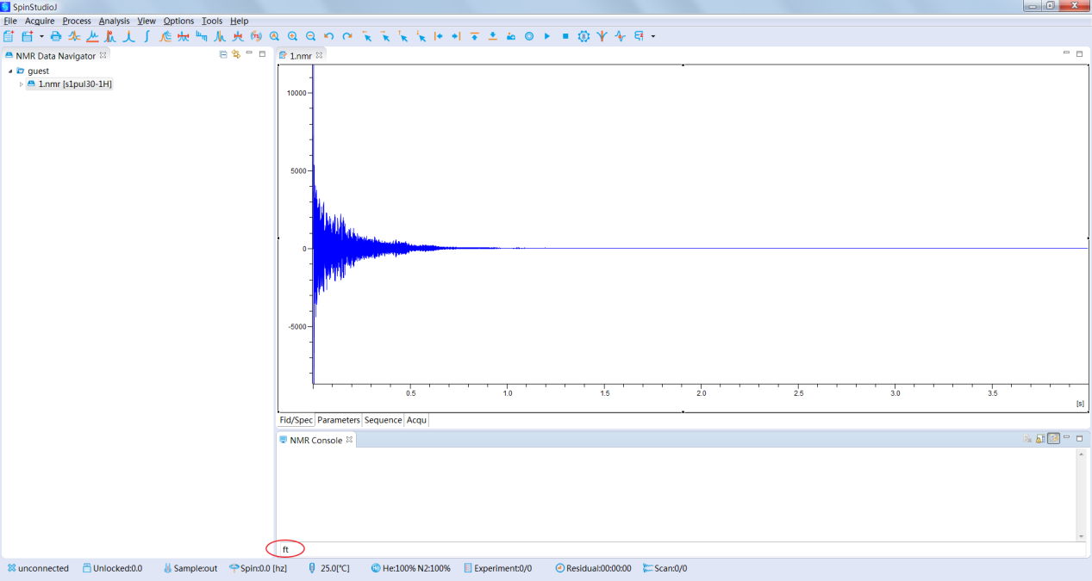
Figure 11. Input “ft” command

6.9 Interactive phase correction
Click the button in the toolbar: 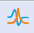, then SpinStudioJ will switch to manual phase correction mode.
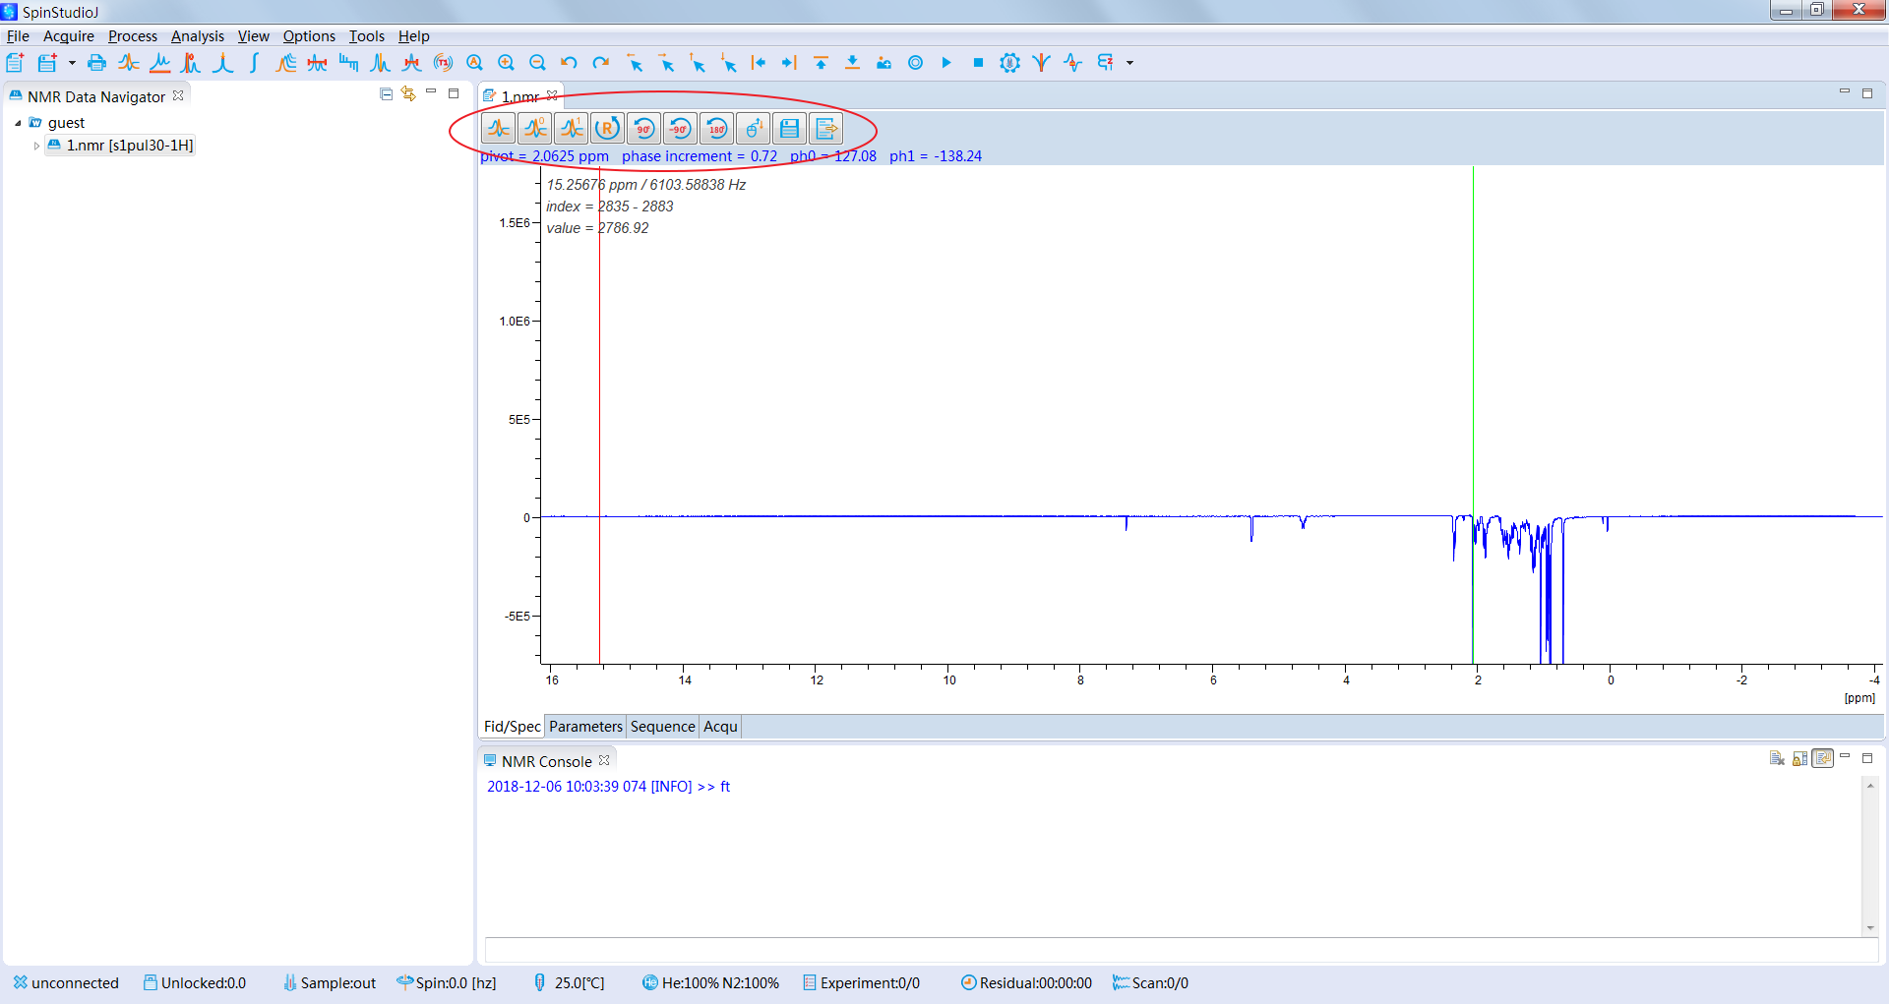
Figure12. Interactive phase correction status

- Zero-order phase correction: move cursor above the button，and scroll the middle wheel of the mouse to correct zero-order phase.
-  First-order phase correction: move cursor above the button，and scroll the middle wheel of the mouse to correct first-order phase.
-  Reset
-  Increase the phase by 90°
-  Decrease the phase by 90°
-  Revert the zero-phase
-  Increase mouse sensitivity
- Decrease mouse sensitivity
-  Save
- 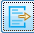 Exit

6.10 Automatic phase correction
Input “aph” command in the command line at the bottom of the main window.
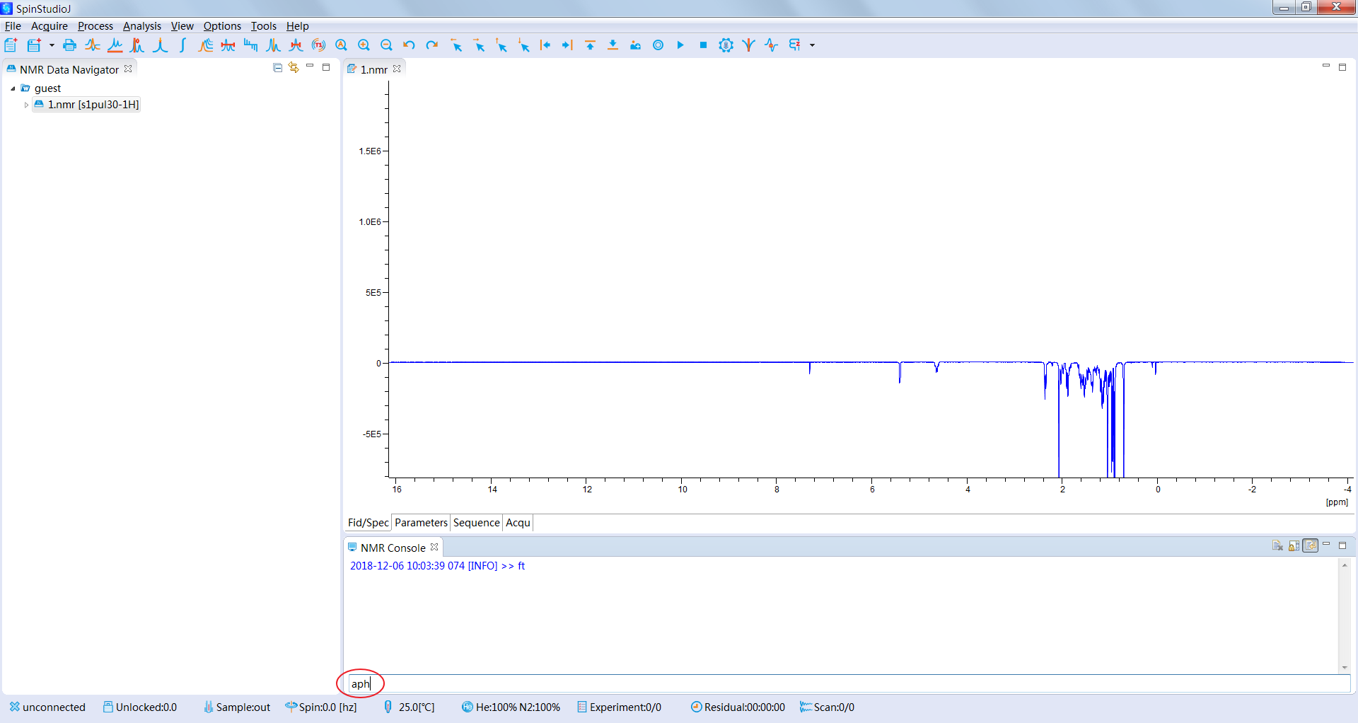
Figure 12. Input “aph” command

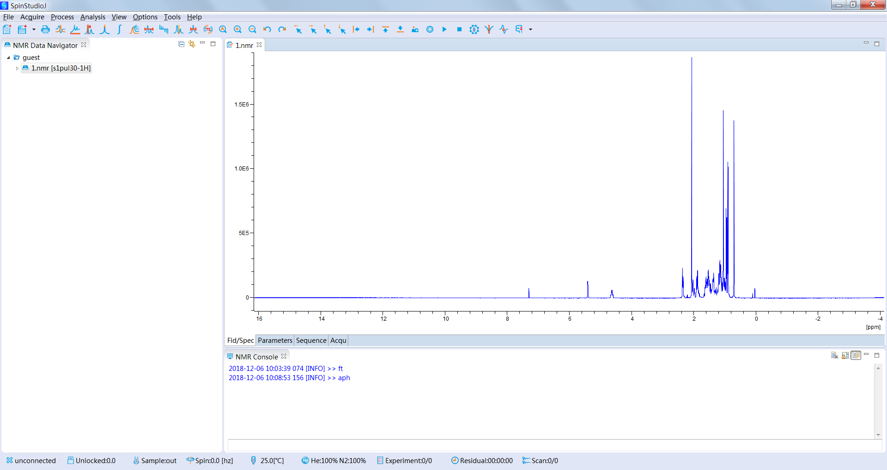
Figure 13. The spectrum after automatic phase correction

6.11 Baseline correction with polynomial fitting
Click the button in the toolbar: , then SpinStudioJ will switch to baseline correction mode.

.
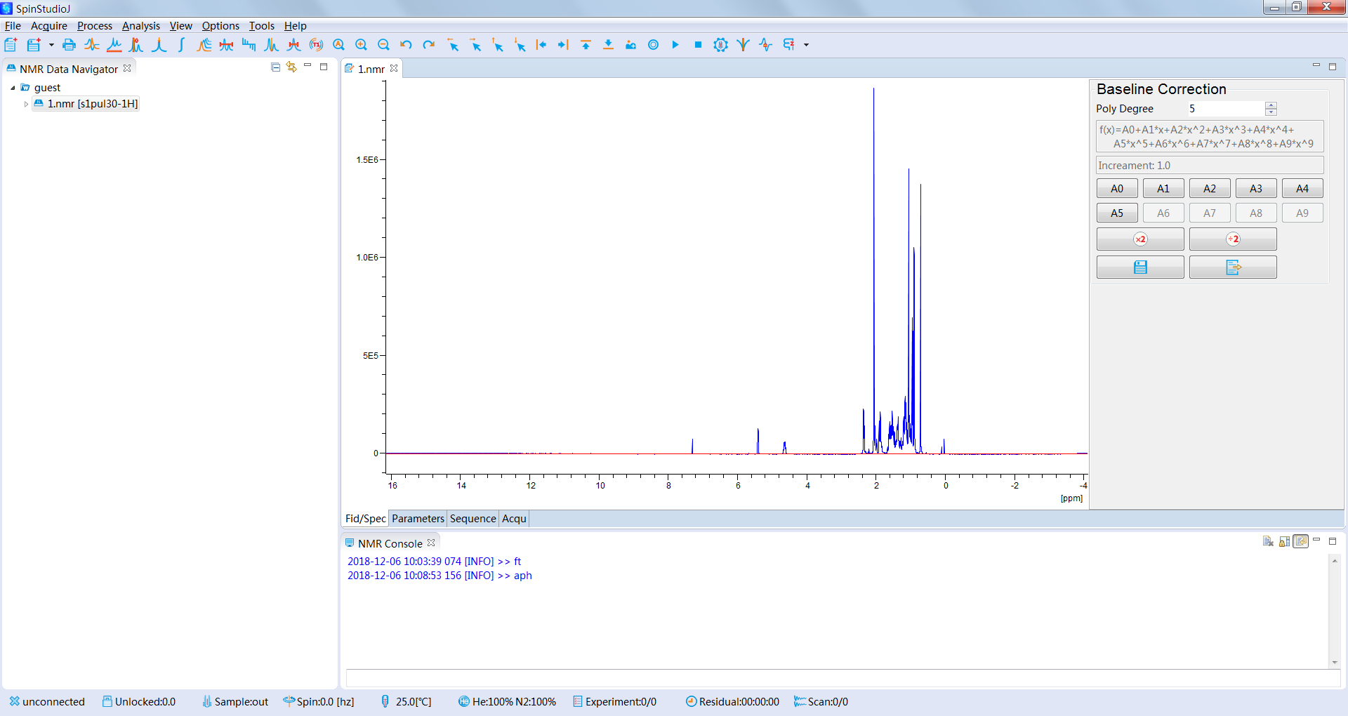
Figure 14. Baseline correction with polynomial fitting

6.12 Spectrum calibration
Click the button in the toolbar: , then SpinStudioJ will switch to manual spectrum calibration mode.
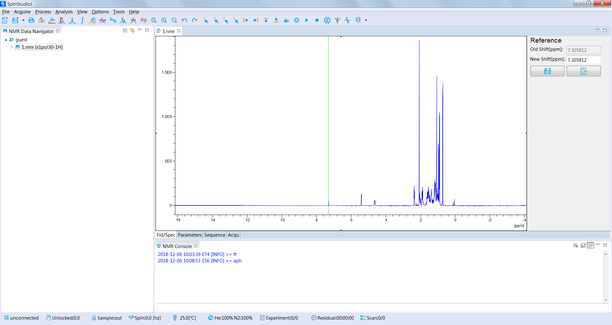
Figure 15. Spectrum calibration

Other data process and analysis functions:
 Manual peak picking
Interactive integration
Multiple display
Distance measurement
Display of arrayed data
Set center freq of the spectrum
 Set spectrum width
Eliminate t1 noise
Show full FID/spectrum
Zoom in
Zoom out
Undo
 Redo
Move left
 Move right
Move up
Move down
To the leftest position
To the rightest position
 To the top position
To the bottom position
Illustration
 Show contour

